RESUME
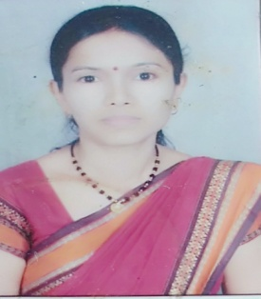
FULLNAME : KU. ARCHANA SUBHELAL AMBULE
FATHER NAME : MR. SUBHELAL WANUSAJI AMBULE
PERMANENT ADDRESS : JITESH CHOWK CHHOTA GONDIA
DIST. – GONDIA 441801
DATE OF BIRTH : 30/09/1982
CONTACT NO. : 9545154600
Email : archuchoudhari9@gmail.com
MARRITUAL STATUAS : MARRIED
GENDER : FEMALE
CATEGORY : OBC (POWAR)
NATIONALITY : INDIAN
RELIGION : HINDU
KNOWN LANGUAGE : MARATHI, HINDI, ENGLISH
HOBBIES : READING, WRITING, PLYING, SINGING

QUALIFICATION
CLASS | BOARD/UNIVERSITY | YEAR OF PASSING | PERCENTAGE
S.S.C. | NAGPUR BOARD | 1998 | 50.80%
H.S.C. | NAGPUR BOARD | 2000 | 57.33%
B.A. | RTM NAGPUR UNI. | 2003 | 48.93%
M.A. | RTM NAGPUR UNI. | 2005 | 57.62%
M.A. ( History) | RTM NAGPUR UNI. | 2020 | SGPA 6.75
B. Ed. | RTM NAGPUR UNI. | 2009 | 60.42%
NET | CBSE-UGC | 2018 | 45.14%
M. Phil | YCMU NASIK | 2007 | 63.00%
MS-CIT | MUMBAI | 2006 | 54.00%

OTHER EXPERIENCE: -
- Six-year experience of teaching in S.S. Girls college Gondia
- One-year experience of teaching in D. B. Science college Gondia
- Three-year experience of teaching in N. M. D college Gondia

DECLARATION
I Declare that the above given information are true & correct to the best of my knowledge
& belief.

Place :- GONDIA Signature
Date - (KU. ARCHANA SUBHELAL AMBULE)

