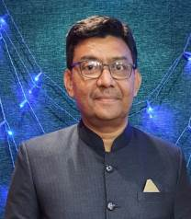
Dr. Shafiulla Khan
Dr. Shafiulla Khan is working as a Head Dept. of English and Coordinator of NAAC, NatwarlalManiklalDalal College of Arts, Commerce, Law and Management, Gondia. He has 32 years of teaching experience, 20 research publications in various national and international journals and 01 chapter contribution in conference proceedings to his credit. He has translated the life of JoomdevMaharaj, a known social reformer ofVidarbha region from Marathi to English which contributed in releasing a postal stamp on the great philanthropist by Govt. of India. Dr. Khan is also coordinator of YashwantraoChavan Maharashtra Open University Study Centre of the college and has worked as coordinator of National Service Scheme of his college unit.

